The Organism is a Storyteller:
Five Organismic Epochs

Part One: From the Primordial Background to σπαραγμος (Sparagmos)
(First presented in 2004 at the Congress of the European Association of Body Psychotherapy on the coast at Marathon a short distance from the most ancient Greek shrine to Dionysus)

Index

Index 1
Prolegomenon 2
Abstract 4
Introduction: five organismic epochs 5
1. Primordial Background 6
2. From Primordial Background to σπαραγμος (Sparagmos) amongst the Ancient Egyptians and Hebrews 9
3. From Primordial Background to Sparagmos in pre-socratic Greece 18
4. Collective Ψυχωσις (Psychosis) in the West 25
5. Conclusion: How do we invert sparagmos… a return to the body… 27
Bibliography 33

Prolegomenon

“All disputes of antiquity and modern times, up to the most recent time are caused by the division of that which in its nature God has produced as one Whole”
Wolfgang von Goethe, Analyse und Synthese

I encountered for the first time a body centred psychotherapy in 1972 fresh out of University, where I had been studying and teaching cultural history in the United States . By the time I moved to Italy a few years later in the late 1970s I had become interested in the nature of animation of the human organism, how that animation breaks down leading to fragmentation and the eventual coming to dominance of a part… usually the head. I was looking for the origin of an all too common ferocious defence by the organism of the disembodied head dominant condition….in which characteristics of the whole erroneously become attributed to the dominant part. At first I began digging around in what might have seemed to be utterly at random. I did not at first really grasp what the accumulating evidence was beginning to tell me when looked at as a whole. For over ten years I studied the early formation of the embryo looking for the developmental conditions in which the whole embryonic organism can break down, and what emerges to hold it together… I eventually presented what to my satisfaction at the time was a sufficient hypothesis in the British Journal Energy and Character (Nathan, 1984, 1986). But something more kept me looking. There was more, something happening collectively that needed nosing out by an historian… And I had the tools… The tools to unveil an organismic story, through which we can demonstrate, amongst other things, the historical necessity and inevitability of a body centred psychotherapy, and some good indications how to practice it…

“If we talk of tradition today, we no longer mean what the eighteenth century meant, a way of working handed down from one generation to the next; we mean a consciousness of the whole of the past in the present. Originality no longer means a slight personal modification of one’s immediate predecessors; it means the capacity to find in any other work of any date or locality clues for the treatment of one’s own subject-matter.”

W. H. Auden (Poet Laureate of England)

Abstract
The theoretical perspective we will apply in this story presupposes a parallel conceptual development: individual and collective. The presupposition on the basis of which we will articulate this entire discourse consists in thinking of the individual and his or her story as concretization of the entire unfolding of human culture and in particular that of the Occident. In our ever so celebrated Occident, in fact, the human condition has reached the most lacerated level of body-psyche fragmentation. Exploring this split we will most easily find the nature of our alienation from the body. The Swiss medical psychologist Carl Gustav Jung was first to formulate the concept of a Collective Unconscious. This concerns a transcendental psychic substrate which for others, and also for us, is concretely organismic in nature. This substrate gathers in itself the archetypal configurations common to all peoples and all cultures in every time and place, appearing and unfolding in a myriad of original and often extremely poetic forms. In other words, the individual organism, in its unrepeatable uniqueness, contains within itself all the acts of the universal Story.

Introduction: five organismic epochs
There exists a body of ancient stories and myths within the collective unconscious still alive in the depths of each of us, which the organism describes as the origin of its actual condition of soul in the present. This is a story of five transgenerational and metahistorical organismic epochs, which narrate in an arc of more than five thousand years the continuous increase of anxiety, growing internal instability, the collapse… and the eventual attempt at recovery of internal sense:
- Epoch of Primordial (Oxford Universal Dictionary On Historical Principles… 1955 [henceforth OED]… underived, original) biological Background… man fully embedded in the organism
“No progress in ethnology will be achieved until scholars rid themselves once and for all of the curious notion that everything possesses history, until they realize that certain ideas and concepts are ultimate for man”. (Paul Radin in Goldstein, 1960)
“Nothing comes to pass in nature which can be set down to a flaw therein; for nature is always the same, and everywhere one and the same in her efficacy and power of action; that is, nature’s laws and ordinances, whereby all things come to pass and change from one form to another, are everywhere and always the same.” (see Spinoza, 1957)
- Epoch of σπαραγμος… Sparagmos… fragmentation
- Epoch of Emergence of Biological Protective Synthesis holding the organism together… while protecting and isolating the primordial background (see Nathan, 1984, 1986)
- Epoch of Re-emergence of Primordial Background (see Nathan, 2006)
- Epoch of the onward adventure of the integral soul
“What true myth concerns itself with is not the disintegration product. True myth concerns itself centrally with the onward adventure of the integral soul.” (D. H. Lawrence, 1977, page 69)

Primordial
Background
Onward Adventure
Background
Re-emergence
Protective
Synthesis
Fragmentation

That which follows will almost exclusively be a deepening understanding of the passage from the epoch of primordial background to the epoch of σπαραγμος (sparagmos), reserving for another occasion study of the other three successive epochs.

Primordial Background
Here we stretch language beyond what language can tolerate, and reach the limits of language. Here we are invited to take a jump beyond language and reason.
As we will now see, a particular process eventually unfolds in different cultures at different times, confirming that we may have here a universal organismic phenomenon, at least in the West.
Since I can not make as tight an argument here as some minds would like, I shall simply present each of these hints (OED… from hent with sense ‘something that can be laid hold of’) as spoor on a hunt: the nature of which being the recovery of internal sense.
Dawn of the Ages
In old stories of old peoples I have come across the following theme: something begins to provoke a collapse of the organism, expressed as a coming apart of the body into pieces… then the body spontaneously and wondrously comes together again. This simple fact gives evidence of a primordial nature… the prototype… that which brings the body together… the capacity to realize one’s own nature…the only real instinct… the urpflanze… as Wolfgang von Goethe and the neuroembryologist and neuropsychologist Kurt Goldstein would say. The great South-African primordial hunter Sir Laurens Van der Post, born on the edge of the Kalahari desert, Godfather to Prince William of England, finds evidence of a primordial nature in a twenty thousand year old story about the Bushmen God, the Praying Mantis.

“I had one clue – the Mantis family were all people of the early race… the Bushman way of saying that they all represented aspects of the first spirit in men… I arrived at what I believed to be their contemporary idiom and human equivalents. The whole suddenly made immediate sense. This sense will emerge, I hope, as we come to each character in the unfolding of the tale.
To begin with Mantis. We meet him already established on Earth and with a long history behind him. We know that he has for many years been the spirit of creation, the meaning, the dream made flesh. He is the image of the great togetherness of life and time, of the whole which our existence on earth only experiences in part. As time goes on, he becomes, however, more and more the image of the differentiated part on earth striving towards a more meaningful reunion with the whole from which it came. One of the very first stories about him made a special point of his significance as a symbol of the spirit of wholeness in life. Once, the story says, Mantis appeared to the children of the early race as a dead Hartebeest. This animal was particularly dear to Mantis - all Bushman stories emphasized the fact. In some stories Mantis appears actually sitting between the horns on the Hartebeest’s head, in others more significantly still between the toes of the Hartebeest, as if demonstrating to the Bushman that the way the Hartebeest walks through life is Mantis’s way. “Mantis”, the little Bushman said, “did not love the Hartebeest a little, he loved him dearly.”
One reason why the Bushman bestowed this highest of honours on the Hartebeest was that his long neck and fine head rather resembled the Mantis, just as the Mantis’s insectlike face resembled the Bushman’s. This resemblance is clearly brought out in Bushman paintings on our rocks. Another reason, I am certain, was that the Hartebeest was, in the high society of the animals of Africa, among the highest - his status equivalent to the Bushman’s. He never moved in great herds like the Wildebeest or Springbuck or the black man, but in small selected family groups like the Bushman. He was one of the most cultured and civilized of animals, surpassed by only one other, the Eland whom we meet later: it is as if, in exalting the Hartebeest thus, the Bushman’s imagination was quickening his own spirit to become the human equivalent of what the Hartebeest was among the beasts of bush and veld.
The impression is confirmed by the knowledge that Mantis always carried a Hartebeest’s skin with him. At moments of danger and other great crises he would wrap himself in this skin; in other words, he would dress his spirit in his own natural attitude and find succour in his own vivid instinct and intuitions, of which the Hartebeest was the glittering symbol. When the children of the early race discovered the Hartebeest lying dead on the veld, though amazed that it had no wounds and was in perfect condition, they cut it up, rejoicing at the good feast ahead of them. But on the way home strange things began to happen. The girl carrying the animal’s severed head suddenly finds its eyes open and winking at her. In alarm they all drop their parts of the carcass. Again they try to take up their loads, and again uncanny things happen; the dead head even whispers at them. They drop their loads, and before their frightened eyes the severed parts of the animal reassemble.
“The flesh of Mantis,” the Bushman said, “sprang together, it quickly joined itself to the lower part of Mantis’s back. The head of Mantis quickly joined upon the top of Mantis’s neck. . . . The thigh of Mantis sprang forward like a frog; it joined itself to Mantis’s back.” And so on, until the children can bear it no longer and run home. When, as a child, I heard the story beautifully read out from Bleek’s rendering, I too felt like running for my mother. Today my imagination is still excited by the story, because it demonstrates Mantis as the spirit of wholeness in life, the element which joins the dead part to a living whole and is active in the apparent death of things. It shows too the Bushman conviction, so important to the understanding of his story, that matter and spirit are mysterious manifestation of one and the same whole.”

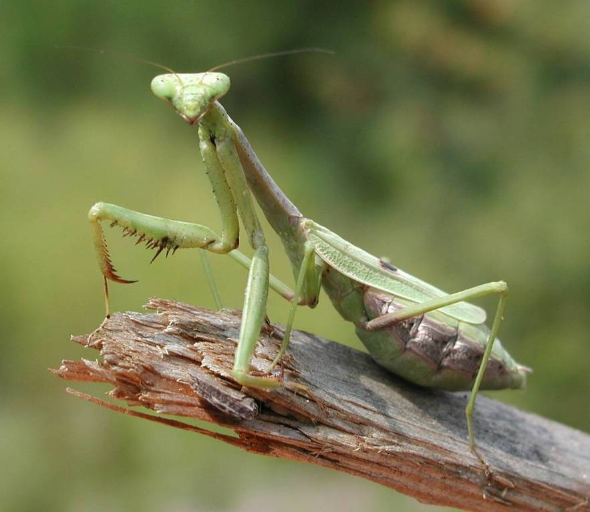
Figure 1: the Praying Mantis
So where does one start backtracking from this primordial prototype to us and our current state of being? The morning of July 14 of 1993 I asked that very question to Sir Laurens during a long taped conversation in his apartment which elsewhere I call the Primordial Hunter World Center, overlooking Chelsea, London. He suggested I backtrack from the original 20,000 year old Bushman culture, a mere 15,000 years, to the historical ancient Egypt of 3,000 BC circa.

“I cannot tell you now from memory in which of his works (at least 32 books, author’s note) Abbé Henri Breuil (1877-1961, author’s note) verifies his comparison between the Bushman and the mention of a prototype in the hieroglyphic records of the Second dynasty (2800-2650 BCE, author’s note). Breuil did a great deal of work in prehistoric painting. Engravings in Dordogne and engravings in the Iberian peninsula, in the Sahara, and ultimately the greatest work of all, the Bushmen art in southern Africa. And he clearly stated that in the hieroglyphic records of the Second dynasty in Egypt there is a description of somebody who can only be the Bushman. Of course, the anatomical characteristic of this person are the characteristics which only the Bushman and no other race in the world possesses: “steatopygia”, the behind that just sticks out, the storing of fat on the buttocks; the phenomenon of a penis that is always heavy, semi-erect… when asked why they were like that they replied “Khoi-Khoi” – “It is just so”. This is a badge of their uniqueness, of their honour, that they are born people just like that; the women have a kind of little anatomical apron, which is called “Couvert Egyptien” to this day. Then there is the evidence that Abbé Breuil finds even more impressive, the prehistoric painting of that period which seems to indicate that the man who painted in Southern Africa where we have thousands and thousands of rock paintings – it is the greatest painting in the world – had a common ancestor in the Mediterranean and North African world and then gradually, God knows why, changes of climate or whatever cause, gradually vanishes and is only to be found to this day in southern Africa” (Nathan, 1993).

From Primordial Background to σπαραγμος (Sparagmos) amongst the Ancient Egyptians and Hebrews
I first really heard the term σπαραγμος (Sparagmos) on the lips of my dear friend, the superb Italian psychiatrist Riccardo Bianco. With whom I was writing in his office deep in the local provincial psychiatric ward on the Swiss border in the mid 1990s, near Lago Maggiore, “Italy’s largest alpine lake”, stretching into the Ticino… Italian Switzerland. We were discussing the fragmentation of a patient with whom we were working together, the fragmentation we saw around us, and the long history of an occidental, if not worldwide, pandemic of fragmentation and its effects in all of the many forms as cause of suffering (see Bianco, Nathan, 1996). Then the phone rang. Riccardo was called to the emergency room of the hospital. After more than an hour he returned… a little stunned, one could say. Sitting quietly in his car overlooking Lago Maggiore, a lawyer had slowly sawed off his own hand… which arrived with him in the ambulance and lay on the table beside him. Ecco σπαραγμος (sparagmos) (that is sparagmos)! I recall Riccardo exclaiming when he returned.
The term Sparagmos in ancient Greek refers to the tearing apart of the body. In modern Greek sparagmos is an emotion so strong that it tears one apart, as an Athenian actress once told me . The word appears in E.R. Dodds, The Greeks and the Irrational (1951). This book was first thrust under my unwilling nose as I dozed off in a freshman classics course, by an overly rambunctious Harvard trained Classics teacher in 1965. I ignored the book and the word for thirty years, until mentioned by Riccardo that day.
How does the organism come to terms with the loss of its wholeness, by which I mean a loss of its primordiality through a progressive process of fragmentation? For the history of Western man’s insight into his own organismic nature is a record of fleeting last glimpses of increasingly fragmented wholeness.
The Egyptians
The Goddess Maā, or Maāt, 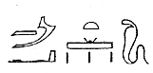, or 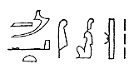, or 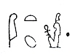
Their belief must be approached sympathetically, entered into and identified with, says C.J. Bleeker (1967). Yet this is sympathy for an almost complete unknown, whose origin must be approximated by virtue of the potentiality in all men of experiencing an urplanze, a prototype of human being which is a given, spontaneously generated, and in its essence immutable, what the Ancient Egyptians called Maā. The grasping of which, some would say, would require such severe reinterpretation to fit our own conceptions of reality, that they no longer would reflect the ancient religion. Bleeker reminds us that it is a scientifically proven fact that in all ages and in all parts of the world regardless of differences in race and milieu, man possesses the same virtues and vices, entertains the same feelings and manifests the same reactions. One could say the ancient Egyptian was similar to modern man and harboured religious feelings not alien to present-day man. (Whether the Ancient Egyptians in their religion had a total absence of individual perception, as Bleeker claims, is very debatable in my opinion for all the primordial peoples as Paul Radin and Kurt Goldstein remind us as well (see Goldstein, 1960)).
In any case, for the Egyptians, the sacred is brought to life… hierophany (ἱερος (hieros), “sacred, holy sign” + φαίνω (phainô), “show, appear”) … through ritual, the renewal of the community and the individual, whose ancient nature has little to do with such stories as the myth of the Godhead of the later Judaism, Christianity and Islam.
The principle of the Goddess Maā (close to the ancient Chinese Tau, et al) expresses the view whereby cosmic life, state policy, the cult, science, art, ethics, and the private life of the individual still form a unity whose structure is not a product of the human brain. Divine order is stable and holds its own, in spite of the fact that from time to time chaotic situations arise, which require re-consolidation of Maā, instituted for all time at the creation. In fact, this primordial background, Maā, remains stable for over 3,000 years (circa 3,900-900 BC, coinciding more or less with what is known as the complete Osiris cycle).

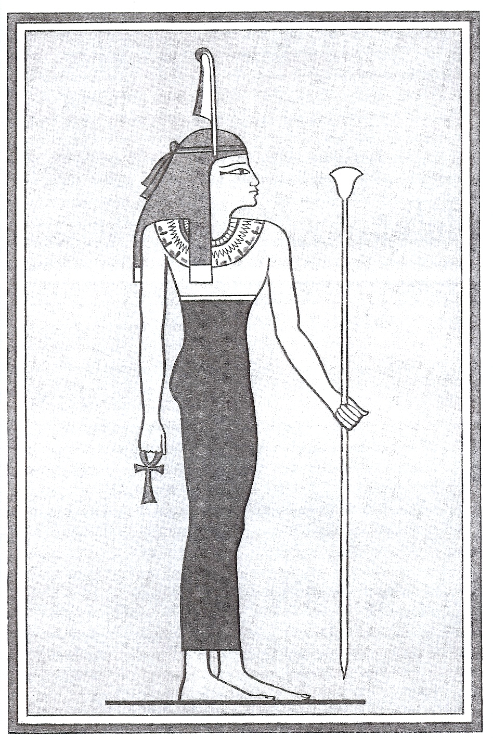
Figure 2: the Goddess Maā

Maā manifests herself in those natural phenomena the lord of which is Osiris… vegetation and consequently also water and earth.
What I have found of creation and animation, that is, of a primordial biological background amongst the ancient Egyptians, revolves around this Osiris, also known as Ausares and Osiris–Is-is.
“The reality about Osiris cannot be easily ascertained as the ancient texts themselves only contain allusions to the vicissitudes of Osiris, which frequently conflict and from which it is difficult to piece together a homogeneous myth. We do know that a famous myth such as that of Osiris was originally of a far more archaic (read primordial) nature and structure than the account as given and provided with a commentary by Plutarch (46-127 AD). We do know that however far back we go there is no coherent account of creation. No writing occurs in ancient Egyptian religious literature that can be compared with the powerful Babylonian story of the creation Enuma elis.”
Nevertheless, in a passage E.A. Wallis Budge translates as “The Creation”, Osiris early in his cycle is alive and active in this world as a vegetative God:
“I evolved the evolving of evolutions… That is to say, I developed myself from the primeval matter which I made. I developed myself out of the primeval matter… my name is Ausares the germ of primeval matter… the primeval matter of primeval matter”. As Budge underlines in a passage entitled “Creation of men and women”, the word evolutions or kheperu means literally rollings, and primeval matter is paut, the original stuff out of which everything was made. (1995, page 23 ff.).
The Ancient Hebrews
גלם (Golem)
The next spoor on our hunt we find in the ancient Hebrew tradition of the Golem, whose first mention appears in the Bible, Psalm CXXXIX attributed to King David (circa 1000 BC).

“My being was not concealed from thee, when I was made in secret, when I was embroidered in the lowest parts of the earth. My substance undeveloped did thy eyes see; and in thy book were all of them written down - the days which have been formed, while yet not one of them was here.”
According to the Ancient Hebrews the earliest stage in the development of the embryo is called golem. Golem literally translated into English means something ‘formless and rolled up’ – an undeveloped enfolded substance. According to the Talmudic tradition of the Midrash Rabbah (Leviticus, XIV, 9), circa 400-500 A.D., a kind of solidifying process occurs in which the pre-embryonic organism first appears: “At first a woman’s womb is full of blood, some of which goes out by way of her menstrual flow, and by the favour of the Holy One, blessed be He, a drop of white matter goes and falls into it and immediately the foetus begins to form. It may be compared to milk in a basin; if one puts meso into it, it congeals and becomes consistent, if not, it continues to be loose”.
Then, the first stage of actual embryonic development begins with the appearance of the “golem” or undeveloped substance and extends through a period of forty-two days or six weeks. The embryo at the end of this period is known as “shefir merukkam”, , or embroidered membrane… The physician Samuel, in the second century studied the embryo at this stage; and we are told that the eyes, nose and mouth can now be distinguished, the whole creature resembling a “grasshopper”. (see Macht, 1911, p.143) In tradition, everything that is in a state of incompletion, everything not fully formed, as a needle without the eye, is designated as golem. God created Adam as a golem; he lay supine, reaching from one end of the world to the other, from the earth to the firmament.

In the Middle Ages arose the belief of the possibility of infusing life into a clay or a wooden figure of a human being, termed golem. (Is the story of Pinocchio a parallel tradition?) The golem grew in size and could carry any message or obey mechanically any order of its master. Created by a combination of letters forming a “Shem” (any one of the names of God), which was written on a piece of paper and inserted either in the mouth or in the forehead of the Golem, thus bringing it into life and action. Around 1550 Elijah of Chelm (Poland) made a golem with a Shem for which reason he was known as a “Ba’al Shem”. The last golem is attributed to Rabbi Davidl Jaffe, in the Russia of 1800. (for the full story see Jewish Encyclopedia)

I associate these musings about the rolling of the original primordial stuff with the first accurate observations, 1300 years later by Caspar Friedrich Wolff (1733 - 1794) of such enfoldings of organic matter in early development, with the aid of a microscope in 1759 (see Nathan 1991, 1986, and 2006). This forming of tubes from undifferentiated matter which so fascinated the Ancients. Equally fascinated the first medical embryologists armed with microscopes in the 17th and 18th centuries, such as Marcello Malpighi in Bologna and Caspar Friedrich Wolff in Saint Petersburg. And continued to so fascinate such a man as the theoretical physicist David Bohm, Albert Einstein’s great apprentice. Who hypothesizes the route back to our primordial background, or what he called the implicate order, via a perception of these very tubes. Which we call inner spaces and which he called world tubes… constituting boundaries… if I may drop into the language of post-quantum theoretical physics… for a “universal flux that cannot be defined explicitly but which can be known implicitly”. “… An infinitely complex process of a structure in movement and development which is centred in a region indicated by the boundaries of the tube”. Bohm founds his entire physics upon the hypothesis of this universal flux… “undivided wholeness in flowing movement” through world tubes. (see Bohm, 1978 and 1985, page 8-11 and Nathan, 1991))
Body and Soul
“In the Old Testament (the Torah), the human organism is essentially unitary, an indivisible amalgam of body and animating principle. Death represents not so much the breakdown of this amalgam as its transfer to a new locale, a shadow other world known as Sheol ( שאול ) …” (Goldenberg, pp.99-100)
Accompanying the great occupations and repressions of Ancient Israel, first by the Persians (550-330 BC), later by the Greeks, and finally the Romans, there emerges a new conception of human nature. The human being slowly and gradually becomes an artificial and unstable combination of body and something else, and death now appears as the inevitable rupture of this bond. “This conception left room for important differences – some might see the two components of personhood as equally valuable, and therefore see death as a great misfortune, whereas others could see the body as a corrupt prison from which the pure spirit or soul longed to be free, and therefore see death as a kind of liberation – but in either case it now became possible – indeed necessary – to consider the ultimate fates of body, on the one hand, and mind or spirit or soul, on the other, as two separate questions.” (op. cit.)
“In the centuries after the completion of the Bible (between 200 BC and 200 AD circa), Jews developed two conceptions of human nature, one that preserved the Bible’s own positive evaluation of the body and one that did not. Each of these conceptions suggested a different way of imagining the bliss that awaits the righteous at some later time: positive evaluations of the body required that the body be restored to life before such bliss could have any meaning, whereas negative evaluation of the body required, on the contrary, that the truly precious part of our being – our spirit, or soul, or mind – be liberated from its material prison to enjoy its own proper reward.” (op. cit.)
“The idea that the body, which seems to decompose and disappear after death, might in fact some day be revived finds its first clear expressions in the biblical book of Daniel, dated by most modern scholars to the times of the Maccabees, around 165 BC. It is plausible to see a connection between the circumstances then prevailing and the acceptance of this apparently new idea. Traditional Judaism was then suffering its first major persecution in its history. Those loyal to the Torah as traditionally interpreted were being rounded up for torture and death, whereas those eager to violate its rules and worship after the manner of the Greeks were being lavishly rewarded for this act of betrayal.” (op. cit)
The new ideas of resurrection and afterlife could be considered the fruit of desperation and catastrophic reaction in this life. Providing promise of stability in an increasingly chaotic world. In any case a splitting of the body and soul it was. This splitting of body and soul was at first resisted in certain circles of the Jewish community, such as the Sadducees (circa 150 BC-70 AD). As late as the sixth century AD, one finds a commentary by Rabbi Nathan on the Mishna tractate The Fathers (Avot) in which the soul is said to die with the body as they are inseparable. “The Sadducees said: “It is a tradition amongst the Pharisees to afflict themselves in this world; yet in the world to come they will have nothing” (Abot, page 39)
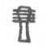Movement into Sparagmos amongst the Egyptians and Hebrews: The Legend of an Os Sacrum
As cycles of desertification, famine and war become ever more dominant, there emerges in the individual a sense of inadequacy in feelings, emotions and ‘so called’ instincts. Instability, anxiety, and stress appear. Tending to an (apparent) condition of permanent fragmentation. This fragmentation is expressed in terms of cutting the body into pieces.
As the oldest continuously retold story in the West goes, sometime early in Egyptian pre-history, more than five thousand years ago, Isis-Osiris lie as ONE cleaved together in the womb of their mother. However, the womb does not contain them in their unity and they split apart. They are thus born apart. Throughout their lifetime they seek to re unite. When Osiris is struckdown, drowned, and killed by his brother, the dark nighttime Set, Isis finds the dead body and hides it from Set. But Set discovers it and hacks the dead body of Osiris into 18 (or 16 or 14 depending on the source) pieces: the head, eyes, ears, nose, mouth, jaws, beard, lips, tongue, trunk, neck, hands, nails and ankles, belly, shoulders, genital organs, os sacrum and backbone, and feet. Set then disperses the body parts throughout the known Mediterranean world…Egypt.. Isis sets out to find the fragments of her dead brother-lover Osiris. Where she finds each body part becomes a holy place dedicated to Osiris. If she ever finds the genitals is unknown.
For millennia Egyptians invoke Isis as the fountain of reintegration and animation of Osiris. “She breatheth on thee, she speaketh words of power, thou movest. She giveth thee thy head, she presenteth to thee thy bones, she gathereth together thy flesh, she bringeth to thee thy heart in thy body.” (Budge, 1972, page 193) At Busiris Isis had found the Os Sacrum and backbone of Osiris. Over time Busiris emerges as the center of the Osiris cult of the “Erection of the Venerable Djed”, on the Egyptian new year in the Fall. In the raising of his backbone Osiris and all Egyptians reanimate and resurrect. “Rise thou up, O Osiris, thou hast thy backbone. O still heart, thou hast the tendons of thy neck and back. Set thou thyself upon thy base. I will set water under thee.” (Budge, 1972, page 65)
At first, Isis does help to raise the backbone of Osiris, which comes to be called the pillar of Djed…  or . This is a hieroglyphic representing Osiris, which appears hundreds of times. And possesses one peculiarity: the Sacrum, which is originally associated with the genitals, sits atop the spinal column. Not altogether an anomaly says Neumann about these genital head inversions. “Each can stand for the other” (1973, page 77).

Figure 3: The Djed Pillar of Osiris: Note the back bone and head split
But over time Isis is no longer the source of integration and animation of Osiris. It is Osiris himself, and increasingly his backbone and os sacrum that seems to animate. “I have knit myself together. I have made myself whole and complete. I have renewed my youth. I am Osiris, the Lord of Eternity.” (Budge, 1995, page 77) This is a turning point in the story. From being an example of a man who had risen from the dead, with whom the Egyptians can sympathize and identify, the King Osiris is becoming a God and the cause of the resurrection of the dead, associated with the ritual raising and/or burying of his backbone and sacrum. The original dismemberment of Osiris is slowly forgotten over the millennia as he comes to be perceived as living in a ‘perfect body’ in the underworld (Budge, 1995, page 61).
The legend of a sacred bone migrates into the Aramaic Talmudic traditions of the Jews. Shortly before the death of my father Ernst Nathan in 1991, I asked him what he knew of this migration. He told me with a surprisingly absolute certainty, that Moses brought the tradition out of slavery from Egypt (circa 1250 B.C., reign of Ramses II). As early as Psalm 34:21 King David (circa 1000 B.C.E.) says “He keepeth all his bones; Not one of them is broken”. By 210 A.D. Rabbi Uschaia writes of a little bone, located at the base of the spine, whose ground substance is of divine origin. Associated in the Talmud with the indestructible ancient City of Luz, whose location, according to tradition, varies including, interestingly enough, somewhere near the southern Lebanon coast in the area of Sidon and Tyre. “That is the Luz in which they dye the blue (the blue of the fringe of the tallis), that is the Luz against which Sennacherib marched without disturbing it, against which Nebuchadnezzar marched without destroying it…” The Aramaic for nut is Lus (Luz). “A nut tree stood at the entrance of a cave; this tree was hollow, and through it one entered the cave, and through the cave the city.” A hidden city into which the Angel of Death cannot enter, and whose inhabitants, whilst they remain within the walls of the city are immortal.
Eventually the sacred bone comes to be called the Bone Luz. The Bone Luz forms the body, animates the body, the soul is attached to it, the soul is protected within it to the end of time when the body will reform around it (to this day one can see orthodox Jews gathering body parts of victims of bombings in Israel, guaranteeing, according to tradition, that all the parts will be available to form around the luz at the end of time). Emperor Hadrian (77-138 A.D.) may his bones be crushed and his name obliterated (FIND TALMUDIC CITATION), for the cruelty of his reign, once asked Rabbi Joshua ben Hananiah how the body will be resurrected in the world to come. “From the Bone Luz of the spinal column”. Hadrian said: “Prove it to me!” Rabbi had one brought. He placed it in water but it did not dissolve, in fire but it was not burnt, in a mill but it was not ground, he placed it on an anvil and struck it with a hammer; the anvil was flattened out and the hammer was split, but the Luz remained undamaged.” (I have found 29 versions, all similar, of the Luz story in the Babylonian and Jerusalem Talmud which date from 200-600 A.D.)
The legend of a resurrection bone is accepted as axiomatic truth by the Apostolic Fathers Origen and Jerome of the early Church (see luz in The Encyclopaedia Judaica and The Jewish Encyclopaedia). The legend filters through Arabic culture. Averroes (died Dicember 10th, 1198) says: “Each Son of Adam returns to dust with the exception of the coccyx bone”. It is called in arabic both Aldabaran, according to Vesalius (De humani corporis fabrica, Basel, 1543, as cited in Garrison), and al ajb in this English translation of the Koran. “Mohammed has taken care to preserve one part of the body, whatever becomes of the rest, to serve as a basis to the future edifice. For he taught that man’s body was entirely consumed in the earth, excepting only the bone ‘al ajb’... and as it was first formed in the human body, it will also remain incorruptible to the last day, as a seed from which the whole is derived” (Sale’s Koran, 1821, page 104, as cited in Garrison). In the eleventh century, another Rabbi Nathan repeats the Luz tradition in his Aruch Completum (pp. 24-25, see frontispiece on my next page). The legend continues to survive in later medieval European fables and into modern German popular culture as the Juden Knochlein or ‘Jew Bone’, which brings good luck. As anatomy becomes a practical working science in the sixteenth century of Vesalius, then under the eye of the seventeenth century lens and the ever more disembodied intellect of the eighteenth and nineteenth century, anatomists search without success for a bone with identifiable sacred qualities. The Os sacrum becomes simply... a bone… said to gain its name from its great size.

“Die Fabel ist vergessen, die Worte sind verklungen „
“The fable is forgotten, the words have stopped ringing”

Joseph Hyrtl, Professor of Anatomy, Vienna, 1888

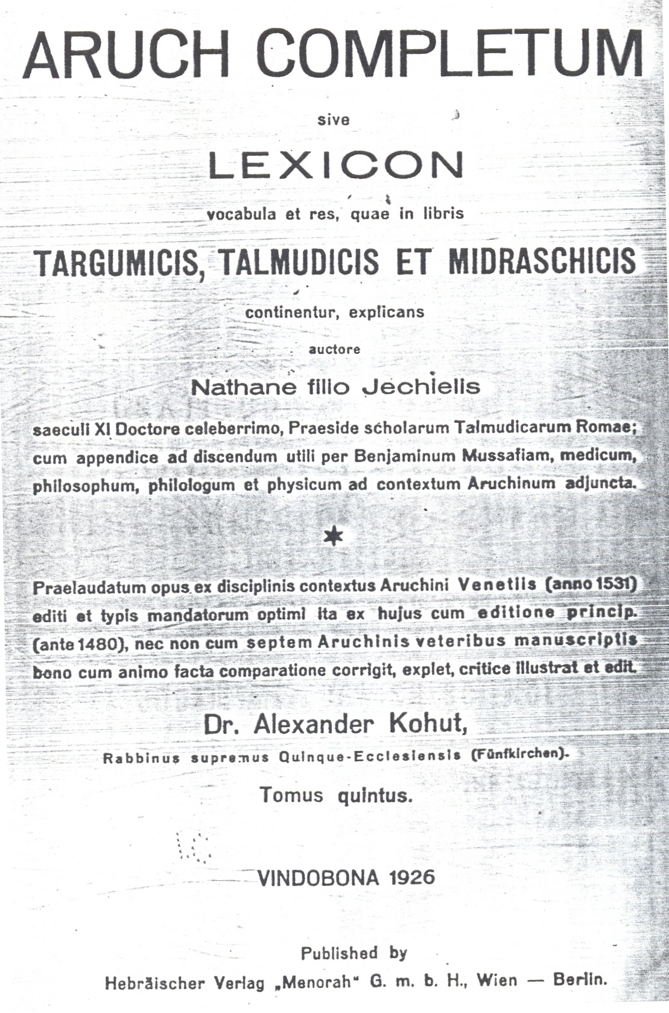

Legend of an Os Sacrum: Interpretation
Myth and legend are the early historical record that reflect for us the ‘stato di animo’, as the Italians say…the condition of animation of the living human organism. The organism itself is telling us something in a language we must learn, in the same sense that the language of the dream reflects and is telling us some thing about the living organism. As the oldest continuously unfolding recorded story in Western history, the legend of an os sacrum is telling us the collective story of the progressive wounding, fragmenting, and loss of internal sensation of the animate human organism in the West.
For causes we would do well to contemplate but which we do not know, at some moment in our history the maternal womb starts becoming unable to contain the wholeness of the embryonic organism. The more peripheral outer oriented mesodermal and ectodermal layers of the organism, I say, begin splitting organismically from the vegetative somatic endodermal core. For the first time in Western history, Psyche starts becoming something independent of Soma. Osiris is losing contact with Isis, the true internal source of animation. When a part which has fragmented from the vegetative core attempts to reunite the organism - that is, when Osiris seeks to reunite with Isis - Osiris only succeeds in energizing the dark shadow of the fragmented whole… Set… provoking by its very nature more fragmentation. And so it is that once Osiris loses contact with Isis, he can only fragment more and more and more.
At first, as the story goes, Isis is still able to gather together the parts of the dead and fragmented Osiris and re-animate him in this life. Which means that for the first few thousand years after Mediterranean man had begun splitting internally into soma and psyche, he retained hope of reanimation in life. By the time Osiris is considered the source of his own animation, we know that the vegetative animating core of being has withdrawn definitively within itself and is no longer sufficiently reaching the periphery of the organism and consciousness. The increasingly isolated and dried up masculine back half of the organism will alone seek to animate the whole. And so an isolated genital cortical circuit (Brown, 1990) along the spine in the back half is ritually raised from the horizontal to the vertical. The practical result of which is the final drying out of the fluid energy flow even in the back half resulting in one more splitting... at the diaphragm. Below the diaphragm in the back half becomes the underworld, where a disembodied Osiris lives in eternity as a shadow of the original Isis-Osiris animating unity. And above the diaphragm the so-called mind/brain, isolated ever more from the rest of the organism, eventually must spontaneously project outside of itself the source of animation as a monotheistic patriarchal God. The Egyptian is promised only the hope of life after death as the animating source is totally disembodied and then transcendentalized. By the time the legend of an Os Sacrum begins migrating, all that seems to be left of an embodied whole is a hard little bone.

From Primordial Background to Sparagmos in pre-socratic Greece
We will be observing the Greek panorama, from let us say 800 B.C. While I was gathering material in twentieth century histories of embryology in the 1980’s to build my argument of an embryonic origin of protective synthesis (vegetative armouring), I kept coming across fragments of so called pre-socratic cosmology. To the early fifth century Heraclitus of Ephesus (535-475 BC) for instance, the world, and thus by extension the body, is an unceasing flux - παντα ρει, ονδεν πενει, all things are flowing, nothing is standing still. All things are forever becoming, nothing ever is. “The Law (of the universe) is as here explained; but men are always incapable of understanding it, both before they hear it, and when they have heard it for the first time. For although all things come into being according to this Law, men seem, as if they have never met with it, when they meet with words (theories) and actions (processes) such as I expound, separating each thing according to its nature and explaining how it is made. As for the rest of mankind, they are unaware of what they are doing after they wake, just as they forget what they did while asleep.” (Freeman, 1957)
The World Egg
While I was rifling through the history of embryology in those days the World Egg kept popping up and grabbing my attention… another little hint about this primordial background. At first the Greeks, for example, made no distinction between the creation of the cosmos, the creation of animate being, and the creation of the body. All is contained in and identical to a World Egg, says Aristophanes (445-385 BC):

Chaos was first, and Night, and the darkness of Emptiness, gloom
tartarean, vast;
Earth was not, nor Heaven, nor Air, but only the bosom of Darkness;
and there with a stirring at last
of wings, though the wings were of darkness too, black Night was inspired
a wind-egg to lay,
And from that, with the turn of the seasons, there sprang to the light
the Desired,
Love, and his wings were of gold, and his spirit as swift as the wind when
it blows every way.
Love moved in the Emptiness vast, Love mingled with Chaos, in spite of
the darkness of Night,
Engendering us, and he brought us at last to the light.
Moving from primordial background towards instability
Whatever was already tending towards fragmentation in ancient Egypt and Israel eventually migrated to the Greek peninsula. I will be cautious treading through this land as I am neither a Greek specialist nor generalist. I am simply following spoor that appear to me. Which could have been equally said about my grasp of Egyptian hieroglyphics, if not for the fact that my own mother Pearl was for years guiding schoolchildren including me through the mummy collection of our local museum, the Rhode Island School of Design, Providence. I always used to joke that my mother speaks hieroglyphics.

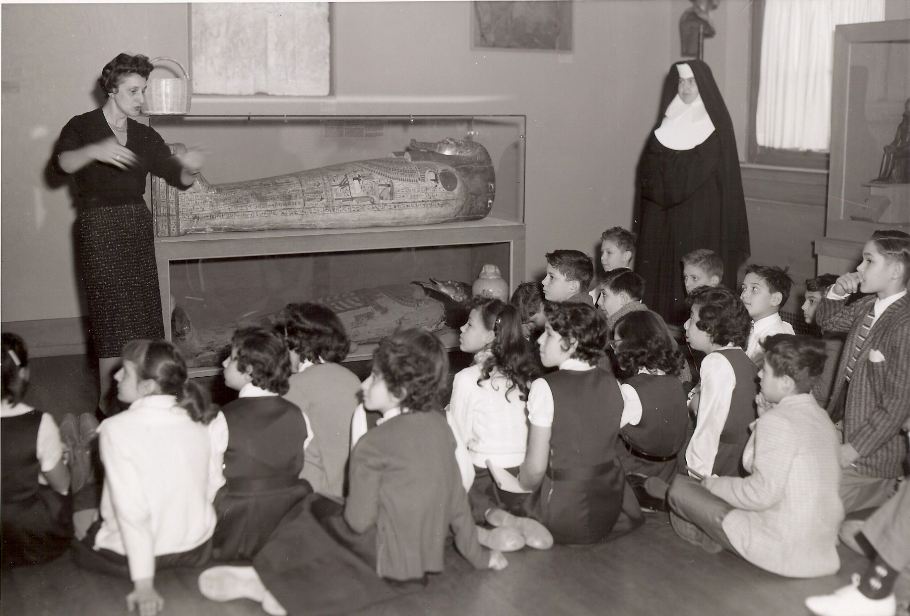
Figure 4: my mother Pearl Nathan speaking hieroglyphic (ca. 1960)

Things are clearly already tending towards coming apart in Empedocles’s (492-432 ca. BC) Greek fragments, written in what is now Porto Empedocle, Sicily. We begin to identify instability and alternation in the Cosmos:
… When Strife had reached to the lowest depths of the whirl, and Love was in the middle of the eddy, under her do all these things come together so as to be one, not all at once, but congregating each from different directions at their will. And as they came together Strife began to move outwards to the circumference. Yet alternating with the things that were being mixed many other things remained unmixed, all that Strife, still aloft, retained; for it had not yet altogether retired from them, blamelessly, to the outermost boundaries of the circle, but while some parts of it had gone forth, some still remained within. And in proportion as it was ever running forth outwards, so a gentle immortal stream of blameless Love was ever coming in… (Fr. 35, Wilford 1968, page 110)
Here Empedocles zooms in on the body:
… This marvellous mass of mortal limbs. At one time all the limbs that are the body’s portion are brought together into one by Love, and flourish in the high season of life; and again, at another time they are severed by cruel Strife, and wander each in different directions by the breakers of the sea of life. It is the same with shrubs and the fish that make their homes in the waters, the beasts that make their lairs in the hills, and the birds that sail on wings. (lines 247-253; DK Fr. 20 as cited in Olney, 1980, page 162)
In this next passage, Aristophanes describes a real splitting of the body at the hand of Zeus:
Mankind… judging by their neglect of him, have never understood the power of Eros. For if they had understood him, they would surely have built noble temples and altars, and offered solemn sacrifices in his honor; but this is not done, and most certainly ought to be done, since of all the gods he is the best friend of man, the helper and the healer of the ills which are the great impediment to the happiness of the race. I will describe this power to you, and you shall teach the rest of the world what I am teaching you. In the first place let me teach of the nature of man and what has happened to it, for the primordial man was round, his back and sides forming a circle; and he had four hands and four feet, one head with two faces looking opposite ways, set on a round neck and precisely alike; also four ears two privy members, and the remainder to correspond... and they were all round and moved round and round… Terrible was their might and strength and the thoughts of their hearts were great, and they made an attack upon the gods… Doubt reigned in the celestial councils… After a good deal of reflection Zeus said… I will cut them in two… After the division the two parts of man, each desiring his other half, came together, and throwing their arm about one another, entwined in mutual embraces, longing to grow into one… so ancient is the desire of one another which is implanted in us, reuniting our original nature, and making one of two… yet they could not explain what they desire of one another. For the intense yearning which each of them has towards the other does not appear to be the desire of lover’s intercourse, but of something else which the soul of either evidently desires and cannot tell, and of which she has only a dark and doubtful presentiment…human nature was originally one and we were a whole, and the desire and pursuit of the whole is called love… (See Plato (428-348 ca. BC), The Symposium, 1956, pp. 352-358).
σπαραγμος Greek Sparagmos
In every time and in every place, one can find myths related to this original disintegration of the body, but the story that best exemplifies the modern condition of psycho-organismic fragmentation we find in ancient Greece. In a culture, that is, that has profoundly influenced our modern view… of the horizons of sense and the current Occidental lifestyle. Just as Oedipus Rex of Sophocles has been used by psycho-analysis as a theoretical and psycho-evolutionary landmark, so, in our opinion, the tragedy of Euripides (ca. 486-406 BC) The Bacchae can be assumed as a foundation of the organismic perspective. In the present work, a particular emphasis shall be placed upon the significance of the terrible events conceived by this author in late fifth century Greece.
For this is the last blow, the sparagmos of Euripides’s Bacchae (431 BC). A tragedy describing a real historical event… the arrival sometime after 1000 B.C. from the North-East, the ancient Thrace , of the Vegetative God Dionysus and his cult in Greece. What happens to Pentheus, King of Athens, by the hand of his own mother Agave, when he denies Dionysus?
Then Agave cried out: “Maenads, make a circle
about the trunk and grip it with your hands.
Unless we take this climbing beast, he will reveal
the secrets of the god.” With that, thousands of hands
tore the fir tree from the earth, and down, down
from his high perch fell Pentheus, tumbling
to the ground, sobbing and screaming as he fell,
for he knew his end was near. His own mother,
like a priestess with her victim, fell upon him
first. But snatching off his wig and snood
so she would recognize his face, he touched her cheeks,
screaming, “No, no, Mother! I am Pentheus,
your own son, the child you bore to Echion!
Pity me, spare me, Mother! I have done a wrong,
but do not kill your own son for my offense.”
But she was foaming at the mouth, and her crazed eyes
rolling with frenzy. She was mad, stark mad,
possessed by Bacchus. Ignoring his cries of pity,
she seized his left arm at the wrist; then, planting
her foot upon his chest, she pulled, wrenching away
the arm at the shoulder - not by her own strength,
for the god had put inhuman power in her hands.
Ino, meanwhile, on the other side, was scratching off
his flesh. Then Autonoë and the whole horde
of Bacchae swarmed upon him. Shouts everywhere,
he screaming with what little breath was left,
they shrieking in triumph. One tore off an arm,
another a foot still warm in its shoe. His ribs
were clawed clean of flesh and every hand
was smeared with blood as they played ball with scraps
of Pentheus’ body.
The pitiful remains lie scattered,
one piece among the sharp rocks, others
lying lost among the leaves in the depths
of the forest. His mother, picking up his head,
impaled it on her wand. (Euripides, 1964, pp. 203-204)

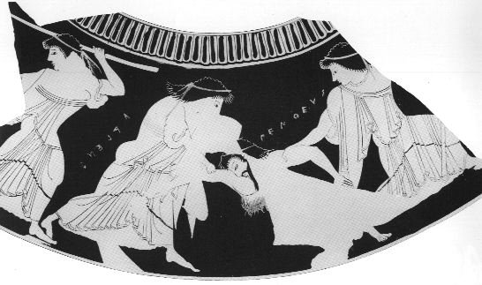
Figure 5: Attic Red Figure Psykter, c. 520-510 BC. Pentheus Being Torn Apart

Dodds’ Old Pattern… θυμος Thumos
Here we have clear evidence of the final breakdown of the primordial background, what the great Oxford Greek scholar E. R. Dodds in 1949 called the breakdown of the inherited conglomerate. Paraphrasing Dodds, until the fifth century B.C. the soul, in Greek psyche, is equated with the personality of the living man. This psyche is the living self, and more specifically the appetitive self. It has not taken over the functions of the Homeric νους nous, which loosely means understanding. But rather of the not so easy to pin down Homeric θυμος thumos.
“The thumos in Homer is neither the soul nor (as in Plato) a “part of the soul”. It may be defined, roughly and generally, as the organ of feeling. But it enjoys an independence which the word “organ” does not suggest to us, influenced as we are by the later concepts of “organism” and “organic unity”. A man’s thumos tells him that he must now eat or drink or slay an enemy, it advises him on his course of action… He can converse with it, or with his “heart” or his “belly”, almost as man to man… for Homeric man the thumos tends not to be felt as part of the “Self”: it commonly appears as an independent inner voice… This habit of (as we should say) “objectifying emotional drives”, treating them as not-self, must have opened the door wide to the religious idea of psychic intervention, which is often said to operate, not directly on the man himself, but on his thumos or on its physical seat, his chest or midriff.”
The terms psyche and soma are interchangeable. Thus as late as the fifth century Sophocles can have Oedipus refer to himself in one passage as my psyche and in another passage as my soma. Dodds admits that “the psychological vocabulary of the ordinary man was in the fifth century in a state of great confusion as indeed it usually is.”
“One fact emerges from the confusion. In fifth century Attic writers as in the Ionian predecessors, the self which is denoted by the word psyche, is normally the emotional rather then the rational self. The psyche is spoken of as the seat of courage, of passion, of anxiety, of animal appetite, but before Plato seldom if ever as the seat of reason; its range is broadly that of the Homeric thumos. When Sophocles speaks of testing ψνχην τε και φρονεμα και γνωμην, he is arranging the elements of character on a scale that runs from the emotional (psyche) to the intellectual (gnome) through a middle term, phronema, which by usage involves both. The psyche is imagined as dwelling somewhere in the depths of the organism, and out of these depths it can speak to its owner with a voice of its own. In most of these respects it is again a successor to the Homeric thumos.”
“What the psyche did not have was any flavour of Puritanism or any suggestion of metaphysical status. The soul was no reluctant prisoner of the body; it was the life or spirit of the body, and perfectly at home there. It was here that the new religious pattern made its fateful contribution: by crediting man with an occult self of divine origin, and thus setting soul and body at odds, it introduced into European culture a new interpretation of human existence, the interpretation we call puritanical.”

Dodds’ New Pattern
By the fifth century the Inherited Conglomerate is falling apart. Due to or accompanied by a generalized, undifferentiated and unattributable anxiety. In the midst of cycles of famine and war. Which brings to the individual organism a generalized sense of inadequacy in the natural world. A sense of guilt appears for the first time in the West. Guilt for a sin committed… the guilt of self fragmentation. Pressure builds to rationalize this guilt.
Dionysus
Dodds speculates as to the root of all this wickedness and guilt.
“It all began with the wicked Titans, who trapped the infant Dionysus, tore him to bits, boiled him, roasted him, ate him, and were themselves immediately burned up by a thunderbolt from Zeus; from the smoke of their remains sprang the human race, who thus inherit the horrid tendencies of the Titans, tempered by a tiny portion of divine soul stuff, which is the substance of the god Dionysus, still working in them as an occult self… the myth is old, founded on the ancient dionysiac ritual of sparagmos and ωμοφαγια (omophagia) (the tearing up and eating of the parts of Dionysus).”

Now to begin with, who or what is this Dionysus?
“he is Δενδριτης or Ενδενδρος, the Power in the tree; he is Ανθιος the blossom-bringer, Καρτιος the fruit-bringer, Φλευς or Φλεως, the abundance of life. His domain is, in Plutarch’s words, the whole of the υγρα φυσις - not only the liquid fire in the grape, but the sap thrusting in a young tree, the blood pounding in the veins of a young animal, all the mysterious and uncontrollable tides that ebb and flow in the life of nature.”
Dionysus then is something deeper and richer and increasingly for the Greek more threatening. For the Maenads were not drunk when they tore apart Pentheus, one who had resisted Dionysus.
“To resist Dionysus is to repress the elemental in one’s own nature; the punishment is the sudden collapse of the inward dykes when the elemental breaks through perforce and civilization vanishes.”
“However this may be, the ωμοφαγια and the bestial incarnations reveal Dionysus as something much more significant and much more dangerous than a wine-god. He is the principle of animal life, ταυρος and ταυροφαγος, the hunted and the hunter - the unrestrained potency which man envies in the beasts and seeks to assimilate. His cult was originally an attempt on the part of human beings to achieve communion with this potency. The psychological effect was to liberate the instinctive life in man from the bondage imposed on it by reason and social custom: the worshipper became conscious of a strange new vitality, which he attributed to the god’s presence within him.”
Orpheus: the Guilt Culture
The story of Dionysus’ sparagmos and omofagia may be attributed to the so-called early Orphic poetry of the sixth century. Of Orpheus himself we know this.
“Orpheus’ home is in Thrace, and in Thrace he is the worshipper or companion of a god whom the Greeks identified with Apollo. He combines the professions of poet, magician, religious teacher, and oraclegiver. Like certain legendary shamans in Siberia, he can by his music summon birds and beasts to listen to him. Like shamans everywhere, he pays a visit to the underworld, and his motive is one very common among shamans - to recover a stolen soul. Finally, his magical self lives on as a singing head, which continues to give oracles for many years after his death.”
How can we relate all this to our current way of seeing things?
“Men were, I suppose, dimly conscious – and on Freud’s (and I would add Jung and Goldstein, author’s note) view, rightly conscious – that such feelings had their roots in a submerged and long forgotten past experience. What more natural than to interpret that intuition (which is in fact, according to Freud, a faint awareness of infantile traumata) as a faint awareness of sin committed in a former life. (Can the embryonic or infantile organism undergo a self-induced sparagmos? Is the memory of this the origin of man’s guilt, at least in the West? author’s note author’s note author’s note)
“That, however, is speculation. What is certain is that these beliefs promoted in their adherents a horror of the body and a revulsion against the life of the senses which were quite new in Greece. Any guilt-culture will, I suppose, provide a soil favourable to the growth of Puritanism, since it creates an unconscious need for self-punishment which Puritanism gratifies. But in Greece it was, apparently, the impact of shamanistic beliefs which set the process going. By Greek minds these beliefs were reinterpreted in a moral sense; and when that was done, the world of bodily experience inevitably appeared as a place of darkness and penance, the flesh became an “alien tunic”… “pleasure,” says the old Pythagorean catechism, “is in all circumstances bad; for we came here to be punished and we ought to be punished.” In that form of the doctrine which Plato attributes to the Orphic school, the body was pictured as the soul’s prison, in which the gods keep it locked up until it has purged its guilt. In the other form mentioned by Plato, Puritanism finds even more violent expression: the body was conceived as a tomb wherein the psyche lies dead, awaiting its resurrection into true life, which is life without the body.”

Collective Ψυχωσις (Psychosis) in the West
What is the next spoor in this detective story of a kind of homicide… of the Body? To what lengths will the already fragmented being go to rationalize a long forgotten guilt? Guilt for having long ago and in each generation again torn apart to the point of non recognition the natural internal embodied flow that leads to the wholeness of the self.
By the Hellenistic period there is a convergence of the so called Bone Luz tradition with that of Greek Sparagmos in the Alexandrine greek writing of Philo Judaeus of Alexandria (20 B.C. – 40 A.D. circa). In his hypothesis of a kind of stream of Gods radiation which will work upon the original unformed matter in the cosmos and by extension the unformed matter of man and in particular the unformed matter of the embryo, the golem.
Just how this stream impresses itself upon matter Philo discusses in perhaps the first ever recorded use of the word Psychosis which appears in Philo’s On the Creation of the World (1929) 1971. The contemporary medical definition of psychosis is a failure or loss of mental powers in activity or movement of the psychic organism amounting to insanity (OED). When the term first appeared in syncretistic Greek literature of the first century, psychosis had, seemingly, an altogether different meaning: a giving soul or life to, animating, quickening, endowment with life, principle of life.

“After the fishes (He) made the birds and land creatures. For when we come to these, we find them with keener senses and manifesting by their structure far more clearly all the qualities proper to beings endowed with the Ψυχωσις (life principle). To crown all, as we have said before, He made man and bestowed on him mind par excellence, life principle of the life principle itself, like the pupil in the eye: for of this too those who investigate more closely than others the nature of things say that it is the eye of the eye.”

In a document entitled Who Is the Heir of Divine Things Philo says:
“The man who is characterized by the blood soul as contrasted with the life of the mind cannot be the Heir. The heir, the mind, must come out of the body, the senses, the speech, and indeed his very self in so far as he renounces his own thought processes.”

Philo here introduces a peculiar term, the λογος τεμεως (Logos Temeus)... the logos cutter… cutting reason… a fire dividing everything. Which then reunites the parts, as the logos cutter is also a glue. Which must be the first description of the formation of the so-called closed cortico-cerebrospinal ganglionic circuits that reunite the pathologically fragmented modern organism in the West, leaving it head dominant.
By 1794 A.D. William Blake has fully unmasked Sparagmos taken to its final extreme, the logos cutter, in his poem, the Book of Urizen:

PRELUDIUM
Of the primeval priest’s assumed power,
When Eternals spurned back his religion,
And gave him a place in the north,
Obscure, shadowy, void, solitary.
Eternals, I hear your call gladly
Dictate swift-winged words, and fear not
To unfold your dark visions of torment.
CHAPTER I
l. Lo, a shadow of horror is risen
In Eternity! Unknown, unprolific,
Self-closed, all-repelling: what demon
Hath formed this abominable void,
This soul-shuddering vacuum? Some said,
‘It is Urizen’. But unknown, abstracted,
Brooding secret, the dark power hid.
2. Times on times he divided, and measured
Space by space in his ninefold darkness,
Unseen, unknown. Changes appeared
In his desolate mountains, rifted furious
By the black winds of perturbation.
3. For he strove in battles dire,
In unseen conflictions with shapes
Bred from his forsaken wilderness
Of beast, bird, fish, serpent, and element,
Combustion, blast, vapour and cloud:
4. Dark revolving in silent activity,
Unseen in tormenting passions,
An activity unknown and horrible,
A self-contemplating shadow,
In enormous labours occupied. [cont.] (Blake, 1794)

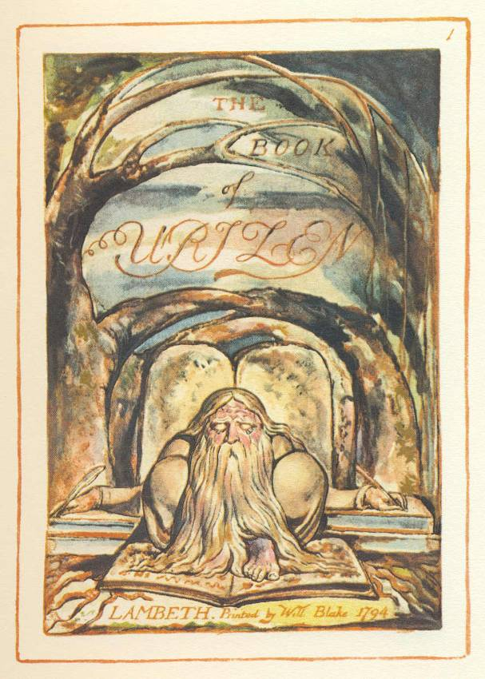
Figure 6: God and his Callipers dividing the World as painted by William Blake in 1794

Conclusion: How do we invert sparagmos… a return to the body…

The recesses of feeling, the darker, blinder strata, are the only places in the world in which we catch real fact in the making.
William James

Anxiety today
The shadow of the unresolved body/mind split exists in the present… “as a man cannot escape from his own shadow, so no generation can pass judgement on the problems of history without reference, conscious or unconscious to its own problems.” (Dodds, 1974 page 253)
Once again in the present we have a choice: splitting or integration? Collective images of bodies blown apart are bombarding us everyday, provoking anxiety. We have more and more need to identify the organism’s natural resources for internal stability. In anxiety disorganization is clearly apparent… an experience of catastrophe, danger, of losing one’s existence. The origin of such Panic Terrors occasioned the news of the death of Osiris says Plutarch: “The first who knew the accident which had befallen their king were the Pans and Satyrs who inhabited the country about Chemmis (Panopolis); and they immediately acquainting the people with the news gave the first occasion to the name Panic Terrors…” (See Budge, 1995, page 46) The emotion is so strong, the danger of going to pieces is so strong… the individual moves to a reduced level of being, a kind of emotionless abstract attitude… URIZEN… The world becomes more “secure”… at the same time becoming progressively more rigid and looses freedom, vitality, and colourfulness… ever more drab (see Goldstein, 1951, pp. 37-49).
Re-emergence of the primordial organism
Using the language of modern physics, Nils Bohr locates the font of internal stability in the inner sphere of the organism… in the acausal seat of that unity of reaction potentialities that constitute an organism (Goldstein, 1995, page 318).
In one of his last great essays entitled The Smiling of the Infant Goldstein clarifies:

“… Self realization means… the realization of all capacities of the organism in a harmonious way so that the existence of the organism is guaranteed. Indeed, the term fits the human organism fully only after the development of the self… the essential meaning of the term is related to the unitary character of what we call a living being, which in a human being manifests itself in the experience of the self.”

Under what natural conditions does the primordial self first emerge?
The smiling of the mother provokes a somatic unity, a sphere of immediacy with the child
- The child draws the smile inwards affirming its centre, bringing a feeling of adequacy
- Which expands throughout the child’s organism… well being
- Only then does the child smile
- This capacity for somatic unity is never lost and constitutes the basis for all future real contact amongst adults (Goldstein 1957, pp. 175-191)

The self-animating being
Body Psychotherapy has no special claim on the call for a return to the body. In a surprisingly neglected book, Depth Psychology and a New Ethic, the man to whom we owe so much for grasping what has really been going on in Western Man for the past 5000 years, Erich Neumann, wrote in 1948 from Tel Aviv:

“…This Self is a limit-concept for the conscious mind - that is to say, the conscious mind cannot apprehend it rationally. But it is possible to say something about its emergence and the form in which it appears.
Before we illustrate the idea of the Self by comparing it with the super-ego, a simple analogy may help to clarify the nature of this concept. When we consider the multiplicity of the transactions which occur in the human body and the incredibly complex hierarchies of interrelationships between the biochemical and the neuro-psychological processes involved (of which only separate partial systems can ever be fully comprehended by science), we are still perfectly well aware that this same body also functions in a unitary way as a single organism possessing a totality. All the various partial systems, from the ultra-microscopic processes (whether perceptible or invisible) in the individual cell to major systems such as the circulation of the blood or the reactions of the nervous system, work together in a co-ordinated fashion and are attuned to each other in a symphony of mutual interdependence.
These processes together constitute a unity, the virtual centre of which is the Self or entelechy, which is a symbol for the phenomenon of the totality of the organism. The total structure in its capacity as a super-ordinate factor above all these partial interrelationships can also be conceived of as a centre, which directs and controls them as its circumference. This control of all partial processes from an invisible centre is the most obvious phenomenon which differentiates the living from the inorganic.
The scientific investigation of causal relationships has nothing to do with this indispensable teleological way of looking at the organism. The Self as the centre of all things psychic, which also includes within itself the processes of the unconscious, is at the same time identical with the totality of the body, since, as we have to assume, and to some extent can already demonstrate, all psychic processes have, at the least, their physical correlates.
This is not the place to discuss the problem - so vital to the psychology of the neuroses – of the relationship between the body and the psyche. We must however, draw attention to the fact that the inclusion of the unconscious always entails inclusion of the body at the same time. When we speak of the earth, then this “earth” is symbolically identical with the body - just as flight from the earth is always at the same time flight from the body. But the totality of the body, in its unitariness and centredness, works unconsciously as a natural phenomenon in everything organic. What distinguishes the human situation, on the other hand, is the fact that in the psychic realm the tension between the opposites of conscious and unconscious has developed in the course of history and has culminated in a separation of the opposites as a whole. This separation between the opposites, the poles of which can be formulated in terms of conscious/unconscious, spirit/life, above/below, heaven/earth or in other symbols of a mythological, philosophical, moral or religious character, is, in itself, indispensable to the development of consciousness; it has, however, been exacerbated to a point where it has proved disastrous for both the individual and the collective. In fact the opposites have been torn asunder so violently that man himself has got lost in the tension between them. As a result, man’s whole position in the world – and not only that, but the whole process which enables human beings to live together in societies - is now very gravely jeopardised.
At first sight, the developmental tendency towards wholeness appears to be no more than an individual requirement; it emerges as such among the individual processes of development in the shape of the need, or rather the urgent necessity, to evolve a stable psychic structure which can stand firm against the tendencies towards disintegration in the outside world and in the unconscious...
…The development of consciousness itself, and everything that has followed in its train, owes its origin to the urgent need for the creation of a stable structure to stand firm against the tendencies towards disintegration in the unconscious and in the outside world.” (Neumann, 1990, pp. 117-119)
Direct touch, the vegetative core and the realm of immediacy
When touching a part, even one in isolation… we are always touching the whole. Touching and styling interventions changes nature when we are aware in our own being… sentience… of the long organismic epoch of sparagmos: which tells of the lengths the organism can go to isolate its vegetative core leading to reduction of being and head dominance. If we succeed in transmitting this fact through direct contact we relieve the enormous collective historical load landing upon each new individual. Then a sphere of immediacy may spontaneously emerge… in which this special sphere of somatic unity, always potentially present in the background, though too often ignored, is more likely to occur between therapist and patient.

For the many hours together discussing and organizing “The Organism is a Storyteller”, my thanks to Luigi Corsi, Philosopher and Psychologist of Livorno, Italy, and to Bjarne Vestergaard, director of the Danish Institute for Conflict Resolution (Faglig Leder, Center for Konfliktløsning).
.

Appendix: On Thinking

Hidden in his last footnote, Dodds concludes: “What we need is not to abandon reason, but simply to recognise that reason in the last three centuries has worked within a field which is not the whole of experience, that it has mistaken the part for the whole, and imposed arbitrary limits on its own working.” (Dodds, 1984, page 279)

“We are thinking for purposes it was never designed” (Van der Post, p.70)

“… his mind was no longer in his head, he had (rediscovered) an older kind of consciousness in his solar plexus” (ibid, p. 70)

“The life of the Bushman was free from the tyranny of numbers. Nature, like civilizations, has his heresies: it too has manifestations that would deviate from the main direction of life and seek to elevate a part of it at the expense of the whole. The first and oldest as well as most contemporary of such heresies, I believe, is the heresy of numbers.” (ibid, p. 202)

“Single vision dis-integrates the landscape, reduces it to bits and pieces, discovers how it works, but not what it means. The action of the parts blocks out the meaning of the whole.”

Roszak, page 277

“While explaining certain observed anomalies in recently discovered pulsars which confirm Einstein’s theory of gravitational field of 1916, the astrophysicist and the interviewer both exclaimed marvel at the ‘brain’ of Einstein. How curious when one recalls how Einstein himself described, for the only time, his own creative process.

“What, precisely, is “thinking”? When, on the reception of sense impressions, memory pictures emerge, this is not yet “thinking”. And when such pictures form sequences, each member of which calls forth another, this too is not yet thinking. When, however, a certain picture turns up in many such sequences, then-precisely by such return-it becomes an organizing element for such sequences, in that it connects sequences in themselves unrelated to each other. Such an element becomes a tool, a concept. I think that the transition from free association or “dreaming” to thinking is characterized by the more or less preeminent role played by the “concept.” It is by no means necessary that a concept be tied to a sensorily and reproducible sign (word); but when this is the case, then thinking becomes thereby capable of being communicated…………………

……all our thinking is of this nature of free play with concepts; the justification for this lies in the degree of comprehension of our sensations that we are able to achieve with its aid. The concept of “truth” can not yet be applied to such a structure; to my thinking this concept becomes applicable only when a far-reaching agreement (convention) concerning the elements and rules of the game is already at hand.

……I have no doubt but that our thinking goes on for the most part without use of signs (words) and beyond that to a considerable degree unconsciously. For how, otherwise, should it happen that sometimes we “wonder” quite spontaneously about some experience? This “wondering” appears to occur when an experience comes into conflict with a world of concepts already sufficiently fixed within us. Whenever such a conflict is experienced sharply and intensively it reacts back upon our world of thought in a decisive way. The development of this world of thought is in a certain sense a continuous flight from “wonder.”

…..A wonder of this kind I experienced as a child of four or five years when my father showed me a compass. That this needle behaved in such a determined way did not at all fit into the kind of occurrences that could find a place in the unconscious world of concepts (efficacy produced by direct “touch”). I can still remember-or at least believe I can remember-that this experience made a deep and lasting impression upon me. Something deeply hidden had to be behind things. What man sees before him from infancy causes no reaction of this kind; he is not surprised by the falling of bodies, by wind and rain, nor by the moon, nor by the fact that the moon does not fall down, nor by the differences between living and nonliving matter.

…..my epistemological (grounds of knowledge) credo……..I see on the one side the totality of sense experiences and, on the other, the totality of the concepts and propositions that are laid down in books……the concepts and propositions get “meaning,” or “content,” only through their connection with sense experiences. The connection of the latter with the former is purely intuitive, not itself of a logical nature. The degree of certainty with which this connection, or intuitive linkage, can be undertaken, and nothing else, differentiates empty fantasy from scientific “truth.”…..Although the conceptual systems are logically entirely arbitrary, they are restricted by the aim of permitting the most nearly possible certain (intuitive) and complete coordination with the totality of sense experiences…..”

Albert Einstein, pp. 11-13

Coming next

Part Two: Emergence of Protective Synthesis.

Bibliography

I really do agree with Kurt Goldstein when he cites Goethe on the subject of citing sources:

“... Provided he presents the material in a refined if not perfected form, the researcher may and must make use of historical predecessors without religiously referring to the source of the material”. (Goldstein, 1995, p 31)

Adelmann, Howard K., Marcello Malpighi and the Evolution of Embryology, in five folio-size volumes, Cornell University Press, Ithaca, 1966 (see chapter 22, The Ancients)
Auden, W. H., “Criticism in a mass society”, The Mint, 2, 1948
Babylonian Talmud, (Seder Zera’im), Trans. Rabbi Dr. I. Epstein, Soncino Press, London, 1948
Baldry, H.C., “Embryological Analogies in Pre-Socratic Cosmogony” in The Classical Quarterly, volume XXVI, John Murray, London, 1932
Bianco R., Nathan R. W., “σπαραγμοζ (Sparagmos): La Frammentazione dal Mito alla Clinica”, Appunti per un seminario didattico, 1996. Also in English as “Fragmentation from Myth to the Clinical, Notes for a Teaching Seminar”, 1996
Blake, William, The Book of Urizen, Lambeth, London, 1794
Bleeker, C. J., Egyptian Festivals… Enactments of Religious Renewal, Leiden, 1967. This is the clearest source I have found on the nature of the Egyptian primordial background
Bohm, David, “The Enfolding-Unfolding Universe: A Conversation with David Bohm” conducted by Renèe Weber, Re•vision, 1978
Bohm, David, Wholeness and the Implicate Order, Routledge & Kegan Paul, London (1980) 1985 (see chapter 1, Fragmentation and Wholeness)
Bolen, Jean Shinoda, M.D., Gods in Every Man, Harper Perennial, New York, (1989) 1990, (see chapter 10, Dionysus… The Dismembered Archetype)
Brown, Katherine Ennis, The Shadow and The Body, a Master’s Thesis submitted to Antioch University, Antioch, 1987
Brown, Malcolm, The Healing Touch: an Introduction to Organismic Psychotherapy, Life Rhythm, Mendocino, 1990
Budge, E. A. Wallis, From Fetish to God in Ancient Egypt, New York, 1972
Budge, E. A. Wallis, Egyptian Ideas of The Afterlife, Dover Publications, New York, (1899) 1995
Budge, E. A. Wallis, The Gods of the Egyptians, vol. 1, Dover Publications, New York, (1904) 1969
Dodds, E. R., G. Murray’s translation of Euripides’ Bacchae edited with introduction and commentary, Oxford University Press, Oxford, (1944) 1974
Dodds, E. R., The Greeks and the Irrational, University of California Press, Berkeley, (1951) 1984
Encyclopaedia Judaica
Einstein, Albert, Autobiographical Notes, Open Court, La Salle, (1949) 1992
Euripides, The Bacchae, translated by William Arrowsmith, University of Chicago Press, Chicago, (1959) 1964
Euripides: Plays, volume two, translated by A. S. Way, J.M. Dent & sons, London, 1957
Freeman, Kathleen, Ancilla to the Pre-Socratic Philosophers, A Complete Translation of the Fragments in Diel’s Fragmente der Versopratiker, Cambridge, 1957
Garrison, Fielding H., “The Bone Called ‘Luz’”, New York Medical Journal, volume XCII, No. 4, New York, July 23, 1910, pp 149-151
Ginzberg, Louis, The Legends of the Jews, The Jewish Publications Society, Philadelphia, (1920) 1980
Goldenberg, Robert, “Bound Up in the Bond of Life: Death and Afterlife in the Jewish Tradition”, in Death and Afterlife, Perspectives of World Religions, edited by Hiroshi Obayashi, Praeger, New York, 1992, pages 97-107
Goldstein, Kurt, “Concerning the concept of ‘primitivity’”, Culture and History, Essays in Honour of Paul Radin, Edited by Stanley Diamond, Columbia University Press, New York, 1960
Goldstein, Kurt, “On Emotions: considerations from the organismic point of view”, Journal of Psychology, volume 31, 1951
Goldstein, Kurt, “The Smiling of the Infant and the Problem of Understanding the Other”, Journal of Psychology, volume 43, 1957
Goldstein, Kurt, Human Nature in the Light of Psychopathology, (Harvard University Press, 1940, 1947, 1963) Schocken Books, New York, 1963
Goldstein, Kurt, The Organism, (Aufbau des Organismus, 1934), with introduction by Oliver Sacks, Urzone, Inc. New York, (1939) 1995
Goodenough, Erwin R., An Introduction to Philo Judaeus, Basil Blackwell, Oxford, (1940) 1962, see pp. 107-108 on Logos Cutter and Logos Glue
Goodenough, Erwin R., By Light, Light, The Mystic Gospel of Hellenistic Judaism, Yale University Press, New Haven, 1935, see pp. 243-247 on Logos Stream and the Logos Cutter
Goodenough, Erwin R., “The Evaluation of Symbols Recurrent in Time, as Illustrated in Judaism”, Eranos Jahrbuch, 1951, Rhein-Verlag, Zurich, 1952
Hay, David M., “Philo’s Treatise on the Logos-Cutter”, Studia Philonica 2 (1973): 9-22
Highwater, Jamake, Anpao, an American Indian Odyssey, Harper & Row, New York, (1977) 1980
Holy Scriptures According to the Masoretic Text, The Jewish Publications Society of America, (5719) 1958
Jewish Encyclopedia
Jung, Carl Gustav, Collected Works, Bollingen Edition, Princeton University Press
Lawrence, D. H., Studies in Classic American Literature, Penguin Books, London, (1923) 1977
Macht, David I., “Embryology and Obstetrics in ancient Hebrew literature”, Bulletin of the Johns Hopkins Hospital, 1911
Marcus Aurelius, Meditations, Book XII (see, as well, Babylonian Talmud, Sanhedrin, 91 B for conversation between Marcus and Rabbin Jehuda on body and soul)
Nathan, Rabbi, Abot (The Fathers according to Rabbi Nathan), translated from the Hebrew by Judah Goldin, Yale Judaica Series X, New Haven and London, 1955 (1983)
Nathan, Rabbi, Aruch Completum, Vindobona, 1926,
Nathan, Richard Wolf, “An Interview with Sir Laurens Van Der Post”, personal taped communication, Chelsea, July 14, 1993
Nathan, Richard Wolf, “La storia più antica della medicina psicosomatica: la leggenda dell’Os Sacrum” (The Oldest Story of Psychosomatic Medicine: the Legend of the Os Sacrum), Atti, volume 1, Historical Symposium, XIV National Congress of the Italian Society of Psychosomatic Medicine, Florence, 1993
Nathan, Richard Wolf, “On the Trail of an Organismic Legacy, Part One” , unpublished, (2006)
Nathan, Richard Wolf, “The Embryonic Origin of Vegetative Armoring: Part One”, Energy and Character, volume 15 n.2, Abbotsbury, August, 1984
Nathan, Richard Wolf, “The Embryonic Origin of Vegetative Armoring: Part Two”, Energy and Character, volume 17, n. 1, Abbotsbury, April, 1986
Nathan, Richard Wolf, “Coelomic Spaces... the application of the Holonomic Physics of David Bohm to an understanding of early embryonic development”, unpublished, 1991
Nathan, Richard Wolf, “Una teoria sulle origini embriologiche della corazza vegetativa” prima e seconda parte, Anima e Corpo, vol 7-8, Editore Stampa Natura Solidarietà, Milano, 1998
Needham, Joseph, Chemical Embryology, in three volumes, volume 1, Cambridge at the University Press, 1931 (see part 2, section 1, Embryology in antiquity)
Neumann, Erich, Depth Psychology and a New Ethic, (Tiefenpsychologie und Neue Ethik, 1948) Shambhala, Boston and Shaftesbury, 1990
Neumann, Erich, The Origins and History of Consciousness, (Ursprunsgeschichte des Bewusstseins, 1949) Bollingen, Princeton University Press, Princeton, 1973
Olney, James, The Rhizome and the Flower, The Perennial Philosophy – Yeats and Jung, University of California Press, Berkeley, 1980
Philo, On the Creation of the World (De Opificio Mundi), translation from the Greek by F.H. Colson and G.H. Whitaker, Harvard University Press, Cambridge, in ten volumes, volume I, (1929) 1971 see p. 51 on Psychosis
Philo, Who is the Heir of Divine Things (Quis Rerum Divinarum Heres), translation from the Greek by F.H. Colson and G.H. Whitaker, Harvard University Press, Cambridge, in ten volumes, volume IV, (1932) 1968
Pini, Mauro, ed. Psicoterapia Corporeo-Organismica, FrancoAngeli, Milano, 2001
Plato, The Symposium, 385 BC, Jowett translation, ed. Erwin Edman, The Modern Library, New York, 1956
Roszak, Theodore, Where the Wasteland Ends, Anchor Books, New York, (1972) 1973
Sandmel, Samuel, Philo of Alexandria, an Introduction, Oxford University Press, New York, 1979
Spinoza, Baruch, The Ethics, (1677) translation by R. H. M. Elwes, Philosophical Library edition, New York, 1957
Stone, Randolph, The Mysterious Sacrum, Pierre Panettier, Orange, 1954
The Oxford Universal Dictionary on Historical Principles, (abbreviated Oxford English Dictionary, hence… OED) The Clarendon Press, Oxford, (1933) 1955
Van der Post, Laurens, The Heart of the Hunter, Chatto & Windus, London, (1961) 1987
Wilford, F.A., “Embryological Analogies in Empedocles Cosmogony” Phronesis, a Journal For Ancient Philosophy, volume XIII no. 2, Royal Vangorcum LTD, Assen, 1968, 108-118

Humpty Dumpty sat on a wall. 

Humpty Dumpty had a great fall. 

All the king’s horses, 

And all the king’s men,

Couldn’t put Humpty together again.

… The only Nursery Rhyme I remember…

In Goldstein, 1995, page 305. This affirmation appears for the first time in Psychology for the explanation of interior phenomena, published in Zur Morphologie (Goethe, 1824).
Department of History, University of Maryland, 1970-1972.
Please refer to www.richardwolfnathan.com for the full text and a collection of all my published articles to date.
“The nose is to the animal what intuition is to the spirit of man: it is the organ which enables the animal to detect what is far away and would otherwise be hidden. We say of a man who has good hunches in his profession that he has ‘a good nose’ for it.” See Van der Post, 1987, page 187.
“The psychotherapist has to acquaint himself not only with the personal biography of his patient, but also with the mental and spiritual assumptions prevalent in his milieu, both present and past where traditional and cultural influences play a part and often a decisive one”. (Jung, C.W. 16, page viii)
In Dodds, 1948, page 237-238. Michel de Montaigne says: “Each man bears the entire form of man’s estate”. Goethe says likewise (in Neumann, 1973, page v): “He whose vision cannot cover History’s three thousand years, Must in outer darkness hover, Live within the days frontiers” Westöstlicher Diwan
I do not exclude that oriental culture has undergone the same fragmentation process, though I have never studied the Orient as such.
C. G. Jung introduces well the depth of the problem in “ Healing the Split” C. W. 18, para 578-607, his last published essay, written in English in 1961.
Cfr. Goldstein, 1995; E. Neumann, 1969; K.E. Brown, 1987; M. Brown, 1990; M. Pini (ed.), 2001. Jung says: “Archetypal image can be taken as intuitive concepts for physical phenomena”. (C.W. 7, para 151)
I actually use Kurt Goldstein’s term, the non conscious, which is less polarizing to me.
I feel well accompanied in this kind of a hunt: “I have presented these old tales neither as curiosities nor as naïve fiction, but as an alternative vision of the world and as an alternative process of history.” The American Indian Philosopher, Jamake Highwater, 1977, page 242 “It is not a peculiar historical interest, a sort of hobby of mine to collect historical curiosities, as has been suggested, but an earnest endeavour to help the understanding of the diseased mind. The psyche, like the body, is an extremely historical structure.” Jung, C. W. 18, para 837 (my italics)
Integral soul… not so easy to grasp, eh…try this… Goethe says (in Neumann, 1973, page 5): “For what the center brings Must obviously be That which remains to the end And was there from eternity” Westöstlicher Diwan
See Richard Wolf Nathan, Primordial Hunter, a 21st Century organismic myth, (see forthcoming publication)
In The Economist of April 26th, 2008, an article appeared demonstrating through a recent study in mitochondrial DNA that all of Humanity originated with and evolved from the Bushmen.
In “The Egyptians” I lean heavily upon the splendid passages of Bleeker, 1967, pages 6-26
Likened to a solidifying agent like curd
See Nathan, 1993. What is known of the story of Isis-Osiris and the Bone Luz as I present it are composites based on the fragments available to us. For example, not until Plutarch’s De Iside et Osiride do we find somewhat of an integral story (see Budge’s translation to the English, 1995). As well I found a mountain of sources confirming my argument thanks in large part to the assistance of Peggy Pearlstein of the Hebraic and Middle Eastern section, Library of Congress, USA. On the other hand, the best single bibliographical source that tracks the spoor on the sacrum, The Bone called “Luz”, was written by the most illustrious Librarian in the history of the USA National Library of Medicine, Fielding H. Garrison, M. D… (See Garrison, 1910). On Garrison’s advice I then turned to Rabbi Kohler’s entry on the Bone Luz in the Jewish Encyclopedia, 1901. See as well the Encyclopedia Judaica (1903). Louis Ginzberg, 1968, is a goldmine on the Luz in Talmudic tradition. Finally the Modern must evaluate the Luz tradition in the light of Erich Neumann’s comments on Isis-Osiris (1973).
And yet today the most common traditional Jewish prayer is called the Amidah , which means standing, while facing Jerusalem, and includes eighteen benedictions… Shemoneh Esreh … associated with the eighteen bones of the spine plus the nineteenth bone, the Luz, and is recited while dovening in which the worshipper rhythmically bends his knees and bows. We find for instance in the Babylonian Talmud: “Mishnah : Every day a man should say the eighteen benedictions. […] Gemara, : To what do these eighteen benedictions correspond? […] To the eighteen vertebrae in the spinal column. […] In saying the Tefillah (“the prayer”, another name for the Amidah, RWN), one should bow down [at the appropriate places] until all the vertebrae in the spinal column are loosened. […] These eighteen are really nineteen? […] the little vertebrae in the spinal column (R. Joshua b. Levi)” (Berakoth, 28b-29a)
J. T. Sheppard’s translation of The Birds cited in Needham, 1931, page 50. The World Egg appears as well in Euripides fr. 48, Aeschylus fr. 44, Apoll. Rhod. I 496 sqq., Lucraetius I 250-251.
The South-western area of the Balcanic Peninsula, bordering the Aegean sea, the Bosphorus and the Black Sea.
Boldface type in all citations of Dodds are by author (RWN)
All above quotes beginning with “Dodds’ Old Pattern… thumos” are drawn from Dodds, 1984 (originally presented in lecture form at the University of California, Berkeley, Fall 1949) See in particular his chapter “The Greek Shamans and Puritanism” pp. 135-178, and his 1974, introduction and commentary to Euripides Bacchae, in particular pp. XI-L
On February 1st, 1980, I received a letter from David Wilson, assistant director of the University of California, Irvine’s Thesaurus Linguae Graecae, a complete electronic data bank of Greek literature, providing first usages of the word psychosis… “The word is not to be found before the first century A.D.” See the Oxford Greek-English Lexicon (1996) and the Oxford Patristic Greek Lexicon (DATE).
A century later Marcus Aurelius (121-180 A.D.) meditates upon psychosis: “To think what each creature is from conception till it receives a soul, till its giving back of the same, and out of what it is built, and into what it is dissolved.” Meditations, book 12, line 24
See Brown, 313.
See OED op. cit. “Psychosis”. I have used as primary source for Philo the Harvard University Loeb Classics series Complete Works of Philo, volume I, On the Creation of the World, (1929) 1971 and volume IV, Who is the Heir, (1932) 1968. I fully adhere to the twentieth century interpretation of Judaic tradition in general and Philo in particular as presented by Yale University professor E.R. Goodenough… see his 1952, and 1935, pp. 243-247 on Logos Stream and the Logos Cutter, and 1962, pp. 107-108 on Logos Cutter and Logos Glue. And Goodenough’s student Samuel Sandmel, 1979 see pp. 97-101 on Logos Temeus (Cutter)
In Dodds, 1984, page 1

